Social Media

Facebook, Instagram: Created and oversaw several pages, created FB ads, geofencing and targeting; and created FB lead ads, surveys, event pages.

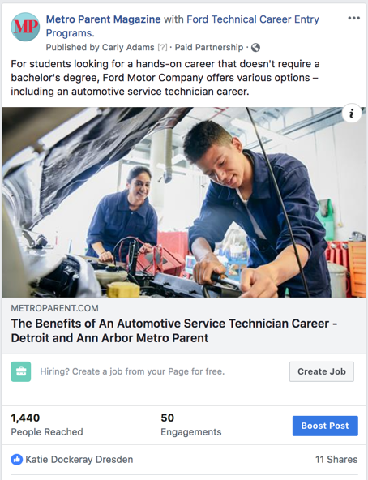

YouTube: Created several channels, including JournalismVideo

