Active Campaign: Engagement Emails

Welcome Series

This is the series of emails that goes to anyone we want engaged with Metro Parent. The emails go out once a week for four weeks, introducing users to all things related to Metro Parent.

NOTE: A FIFTH email was planned for when we have the Events Landing Page designed. That is something Kelly has been working on for a few months. Once that’s ready to go, you may want to execute on this, so that the EVENTS piece of what we do is clear to readers/users.

Stats so far:
Sent to: 11,398 people so far
Open rate: 30.15%
Click-to-open rate: 20.14% (692 clicks)
Most clicked:
Family-Fun Things To Do This weekend -- 183 clicks
Free events in SE Mich -- 153
Freebies -- 140
Update my account -- 135

What you need to know:
- These emails should be refreshed every 6 months or so. That means they are due. We started the Welcome Journeys late in 2018. I’ve swapped out a few things here and there, but have not wholesale refreshed the content.
- Content injected in these should be evergreen to some extent. Not totally set-it-and-forget-it, but pretty close. No one has time to go in and update weekly or monthly.
- Any user who enters the MP funnel should go into this, as long as they have not gone through the campaign already. So the trigger is being added to a list and NOT having gone through the Welcome Series already. Also, anyone added to a BLAC list should not be added.
- INTEREST TAGGING
  - The FIRST email has a INTEREST-FOOD tag. If we change the story to something else, either take this off or change it to a different interest tag.
  - The THIRD email is tied to an INTEREST tag (INTEREST-ACTIVITIES). This list can be used to send directly to users for purposes of letting them know about the new Fun Guide, or events-based emails. They are especially engaged in searching or reading about ACTIVITIES and thus a good target for such emails.
  - The FOURTH email has an INTEREST-ACTIVITIES tag. If the freebie is anything other than Fun Guide or activites-related, change or remove this tag.
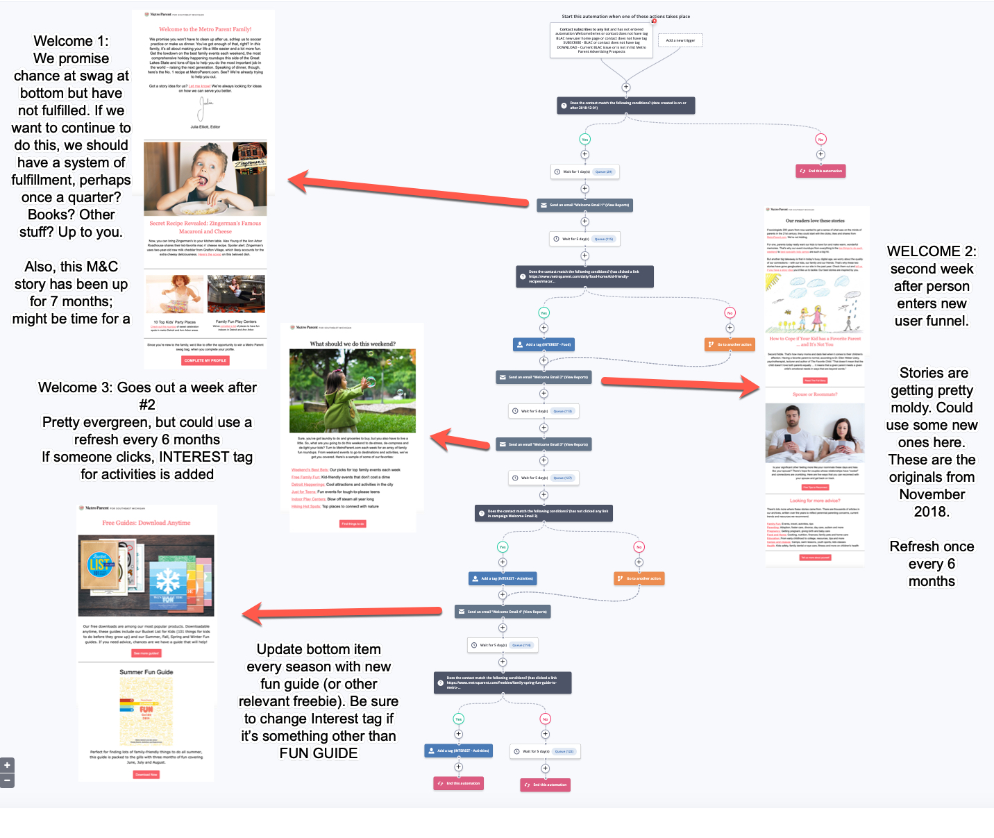

ENGAGEMENT SERIES

This is a “set-it-and-forget-it” series of two emails that I set up in conjunction with our Active Campaign rep. It pretty much runs on its own. Here’s what it does and how it looks:

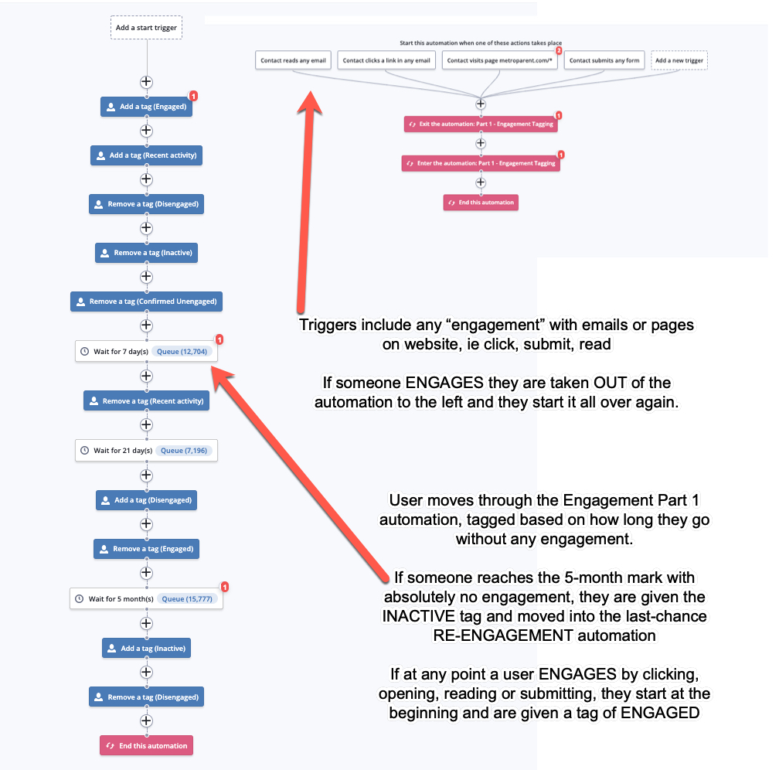

Re-engagement Automation

If a user goes 6 full months without engaging with us -- through email or on the website --they are given one last chance to re-engage through this automation. If they do not respond, we THEN remove them from all lists and they are no longer ACTIVE contacts. If a user engages again with us, they are “re-activated.” In this way, no contact is lost to us -- just deactivated.

The emails: There are three in all. If the user opens or clicks on anything in any of these emails, they are “re-engaged” and no longer in the unengaged funnel. They have 6 more months of complete disengagement before they are readded.

Stats:
Sent to: 35,460 people in total
Open rate: 8.49% (2,385 people) -- these are people who we would have written off, but gave a last chance to -- and they “came back” to us.

Currently tagged:
Re-engaged: 17,535 (Re-engaged as a result of our campaigns)
Engaged: 19,783 (number of people who have engaged with us in the past 7 days)
Confirmed unengaged: 12,642 (THESE are the users we have dropped from our lists)

