Audience tagging and tracking

Freebies and Downloads

Freebies and downloads are tracked in both Active Campaign and Google Analytics.

Active Campaign:
- Every download is associated with a “tag.” Every person who downloads the freebie is given that tag, and that person’s profile will always carry the tag. This is a better and more permanent way of tracking downloads because adding someone to a list can be temporary:
- A person can have themselves removed from lists, but has no ability (or even knowledge) that have a tag associated with them. In this way, we can see a person’s total history. Here’s an example:

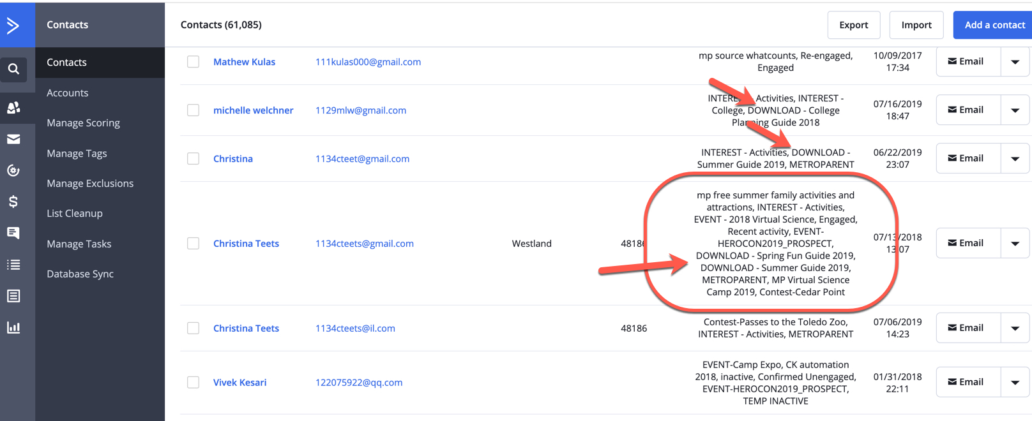

Freebies/Downloads have an automation that both tags the person who signs up for the download and also generates an email to them. Because this automation is autonomous, it can continue to run even when you update the freebie or download in question. Only the new TAG needs to be created. In this way, you can keep track of total downloads of a particular freebie by looking at the tag for that year -- and once the new version is added, just look at the TAG for that year.

Here’s the process for updating and tracking a particular Freebie-Download:

Step 1:
Download is created and prepared by editorial, and both Freebies landing page and specific landing page are updated. You ONLY need to update the copy and image -- no need to update the actual Thrive Element UNLESS you are changing the tag that triggers the automation (see below for explanation if you do need to do this)

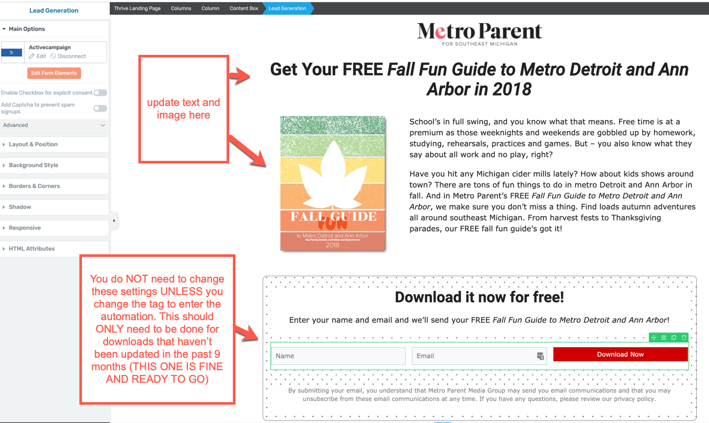

Step 2:
Create new DOWNLOAD tag in Active Campaign for latest version (I’ve already done this for the Fall Freebie 2019, so I can show you how it’s done)

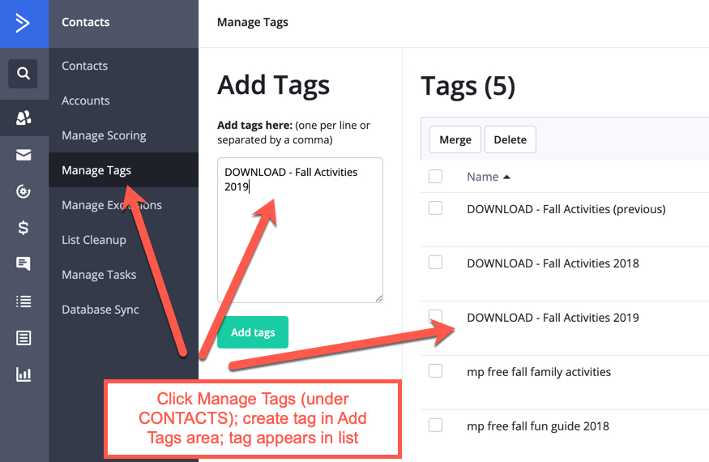

Once you have created the tag, there should be one from the current year and one for the new download. The currently active one should show a number of downloads and that it’s attached to an automation; the new one should have zero contacts attached and a “0” for automations it’s associated with (because it’s not attached yet)

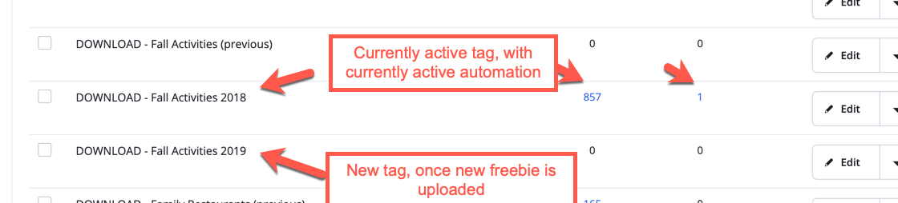

Step 3:
Change the email and tag in the automation to match the new tag.
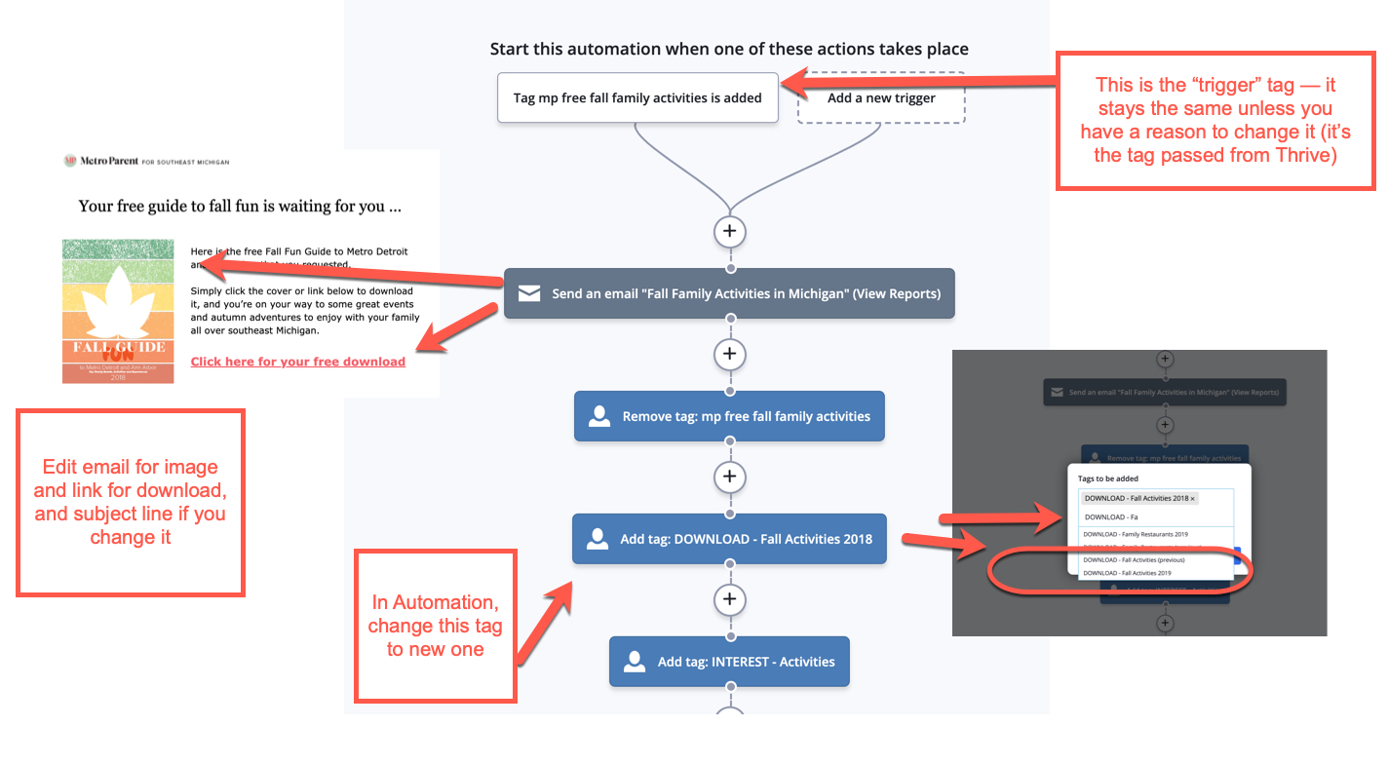

To reiterate, you should not have to change the Thrive box or the trigger tag -- but if you do have to do so, make sure you change them in these three places to ensure tracking and consistency:

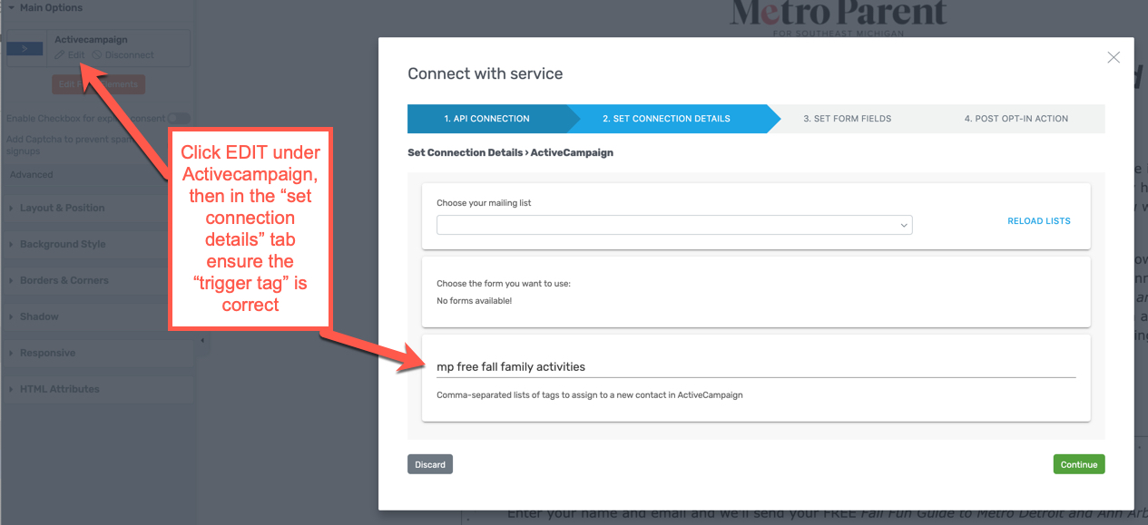

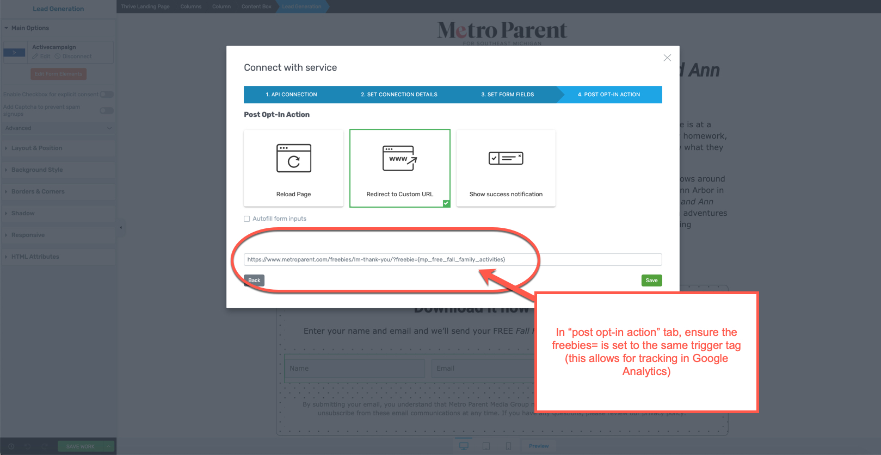

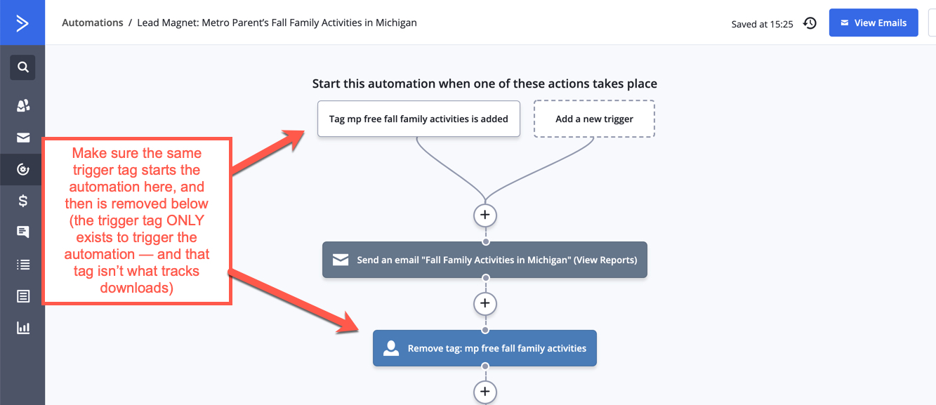

One more thing to check, in the TRIGGER action at the top:

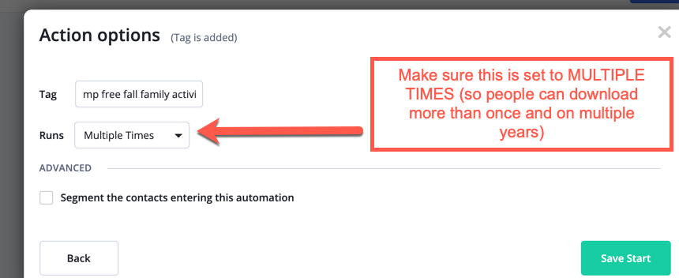
Tracking number of downloads
There are two ways of tracking downloads. The number represented in the DOWNLOADS tag in Active Campaign (which also gives you the list and emails of those who did so) and Google Analytics (which allows you to see in aggregate how many overall downloads there have been over time).

In Google Analytics:

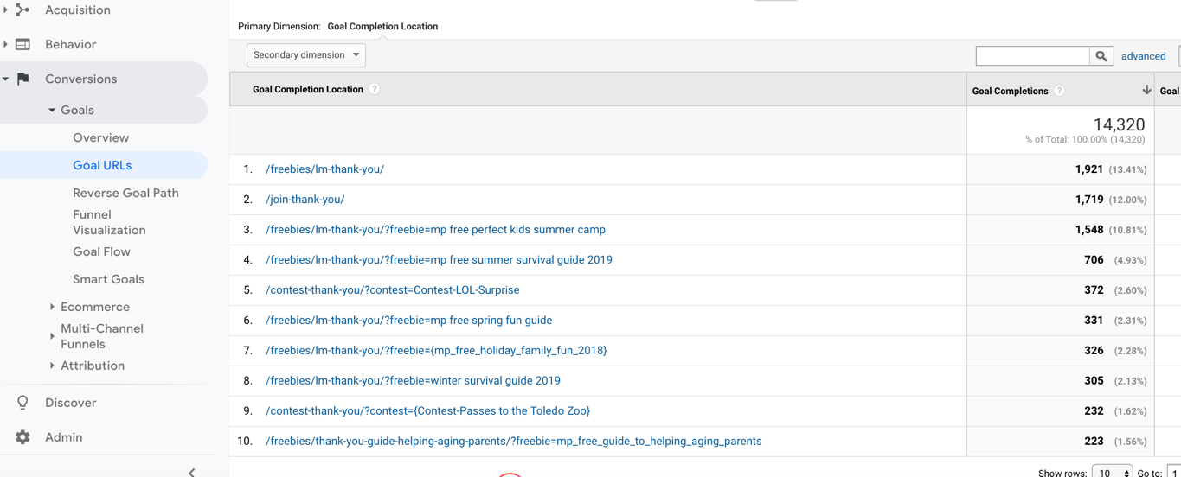

In Active Campaign:

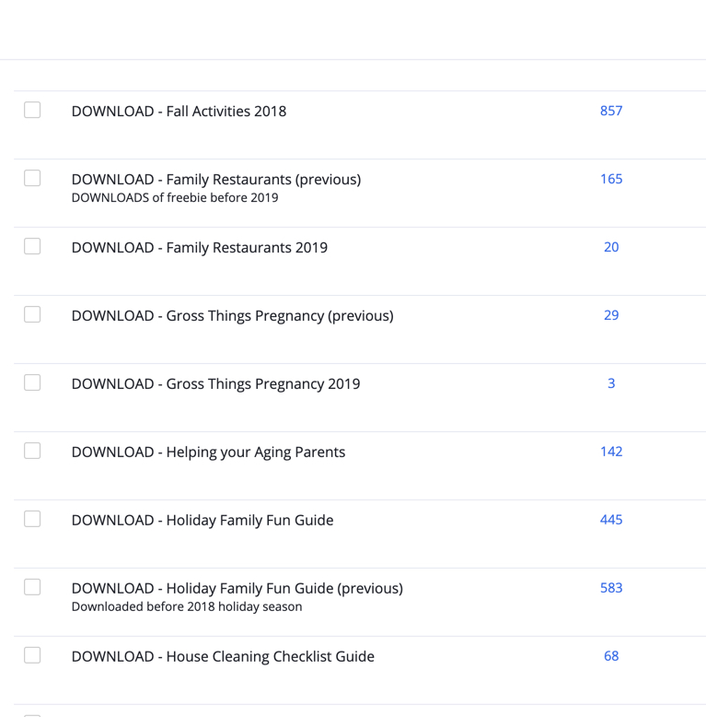

Contests

Once a contest is entered into ViralSweep, there are just a couple of things you need to do to allow us to track all entrants and get them in our email system:

- Ensure under TRACKING & INTEGRATIONS that you choose MP Contests as the list
- Add tag for name of contest : CONTEST - Name of Contest
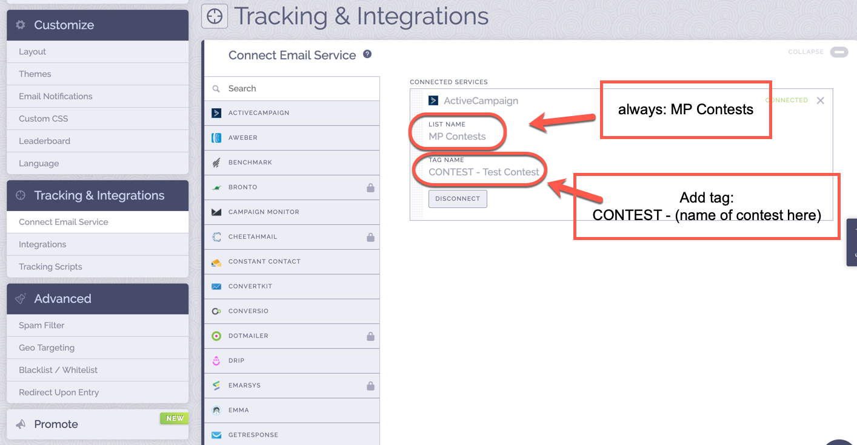

In redirects, ensure that the name of the contest is specified in the URL:

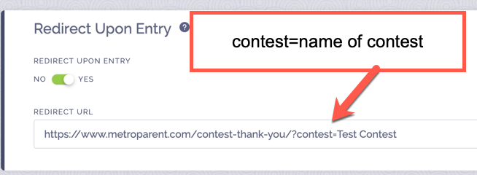

In Active Campaign, here’s what happens:

- Contest entrant enters MP Contests automation, remains on MP Contests list, and goes through the New User Automation (alternative) if he/she hasn’t done so before.
- A tag is added for INTEREST - Contests to track all people who enter the system this way. Someone can be removed from lists by request -- but the tag will stick with him/her for tracking purposes.
- The individual CONTEST will be tagged as well; because there is a unique tag for every contest, that tag will follow that entrant. In this way, you can see in aggregate the people entering contests, and you can see specifically who enters which contest.

Tracking and seeing Contest entrants in Active Campaign

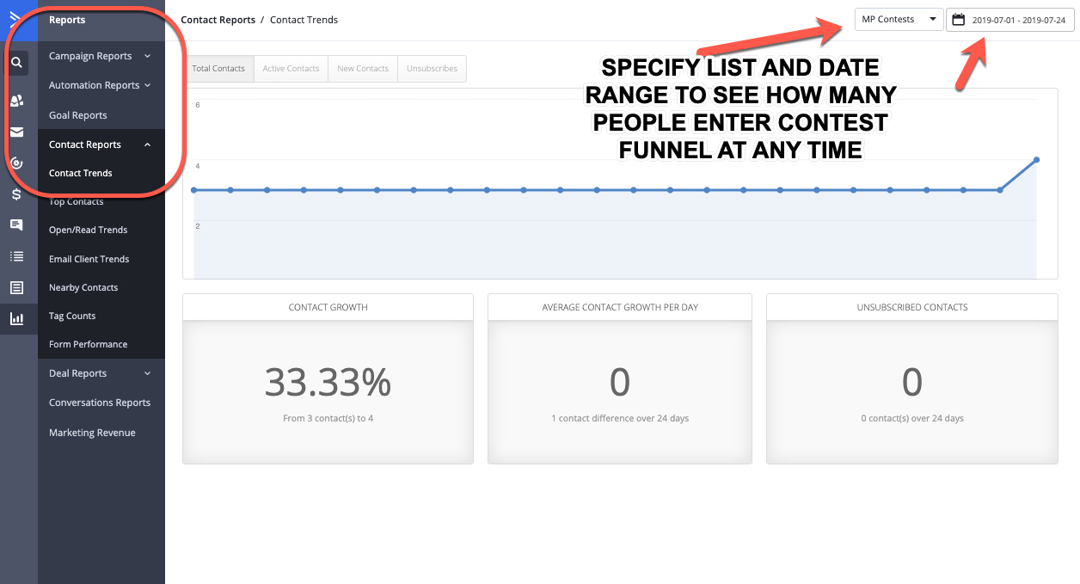

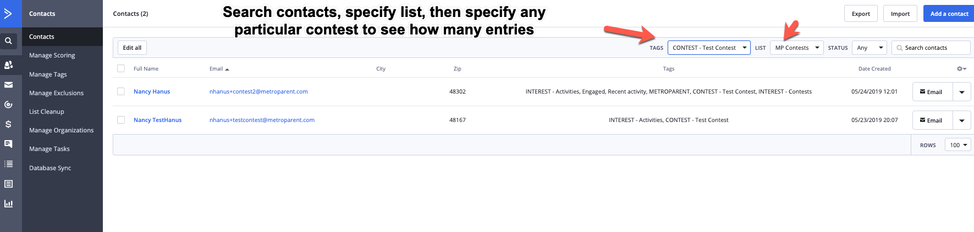
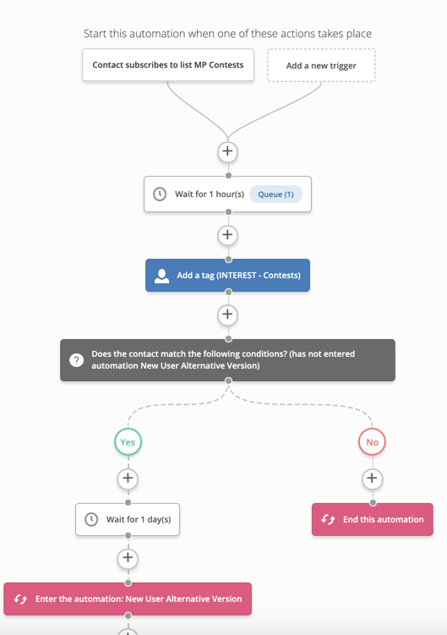

In Google Analytics, here is what happens:

