URL Tracking: How-Tos

Contests

All contests in Viralsweep should point on entry to a thank you/confirmation page on the site:

https://www.metroparent.com/contest-thank-you/

In Viralsweep, Under Advanced → Redirect Upon Entry area, change to YES and add the URL, plus the tracking suffix, which should be:

?contest={name of tag in Active Campaign}

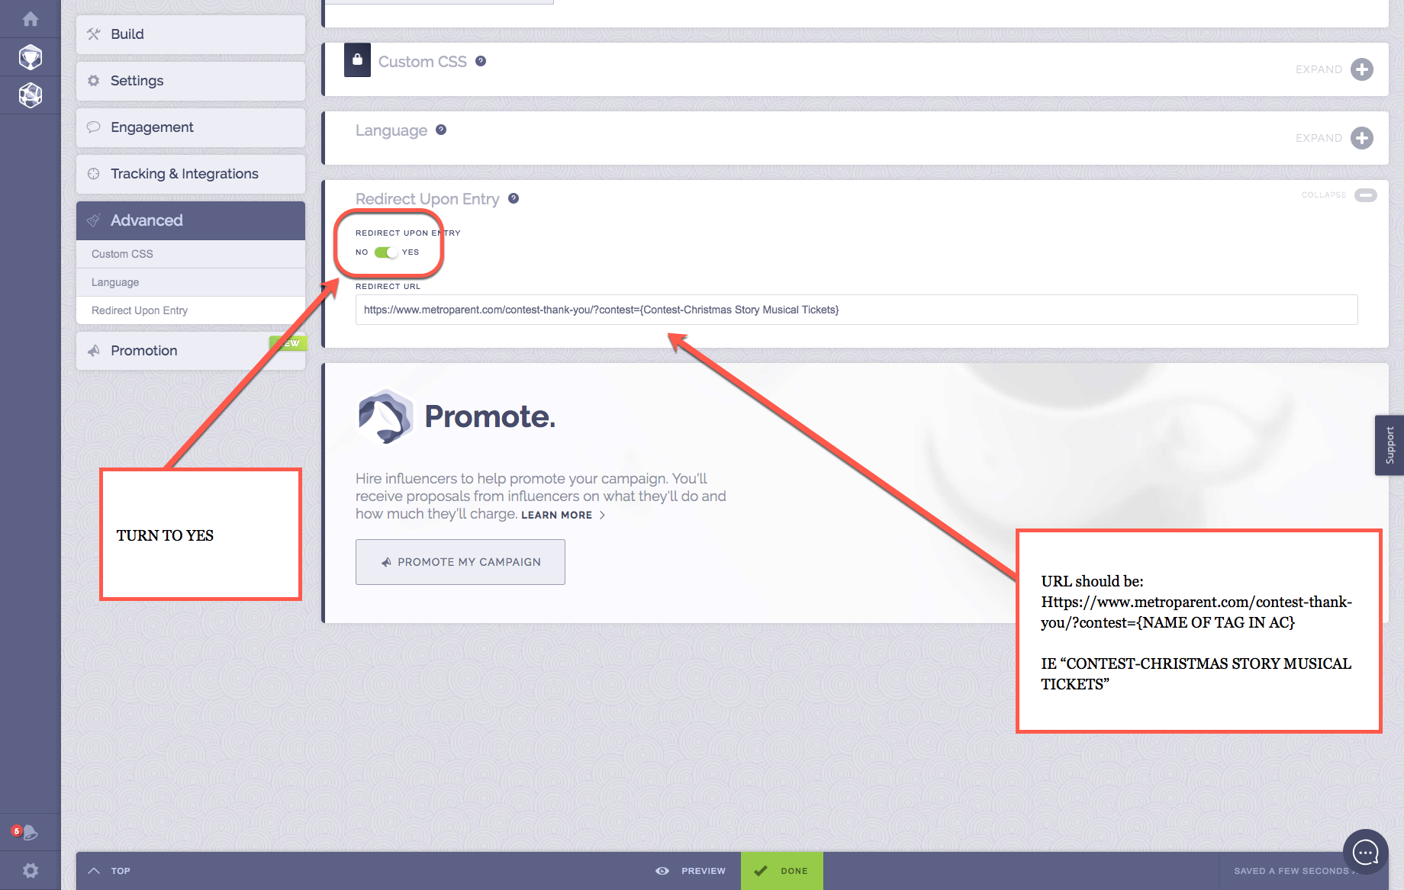

Freebies

Freebies downloads are already redirecting to general THANK YOU page:

https://www.metroparent.com/freebies/lm-thank-you/

Or a specific one (for College Guide; there may be others):

https://www.metroparent.com/freebies/thank-you-college-download/

So that we can track the specific downloads in Google Analytics, we need to add this suffix to the URL for tracking purposes (in the ACTIVE CAMPAIGN EDIT integration):

?freebie={name based on tag in Active Campaign}
(example: ?freebie=christmas_story_tickets)

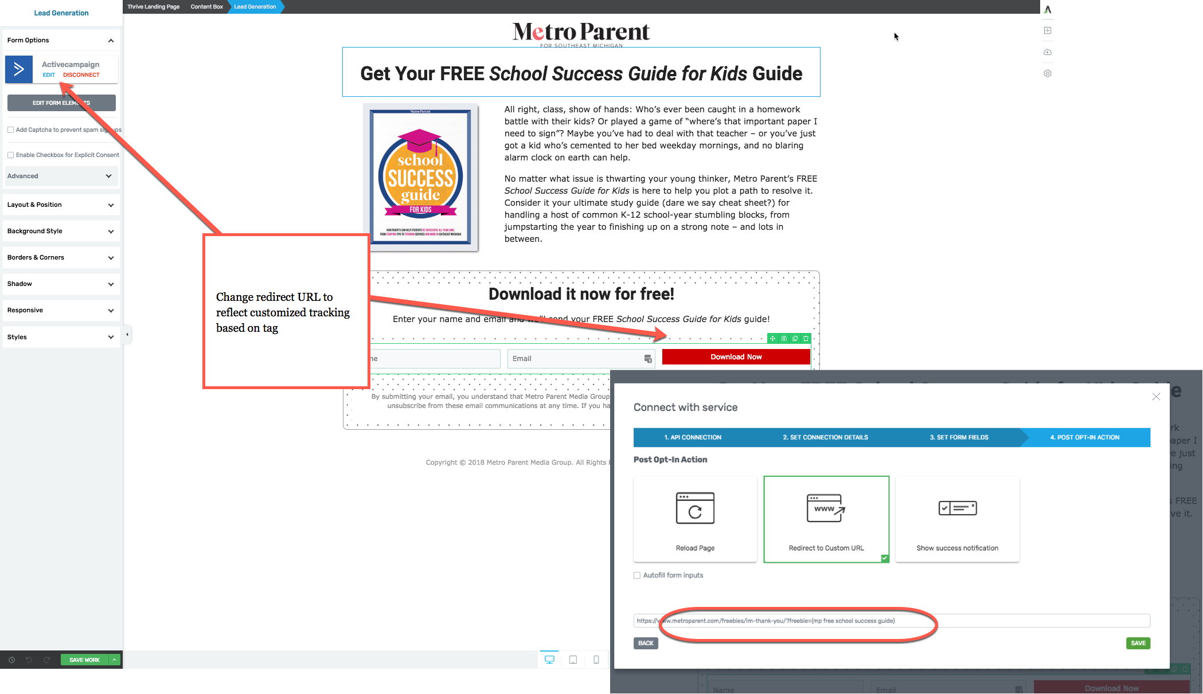

House ads: Website

Create UTM codes for all ads with the following using the campaign URL builder:

Source=metroparent (or source=blac)
Medium=banner
name=campaign_name (ie advertise_with_us)
content=creative (ie word_of_mom)

EXAMPLE:

https://www.metroparent.com/about-us/advertise-us/?utm_source=metroparent&utm_medium=banner&utm_campaign=advertise_with_us&utm_content=word_of_mom

Email MP leads and house ads

Create UTM codes for all MP and BLAC ads and elements within emails, using the UTM builder. Follow the following taxonomy:

Ads:
Source=metroparent (or source=blac)
Medium=email
Name-campaign_name
content =creative description

Freebies:
Source=metroparent
Medium=email
Name=freebie
Content=name_of_freebie
Contests:
Source=metroparent
medium=email
name=contest
content=name_of_contest

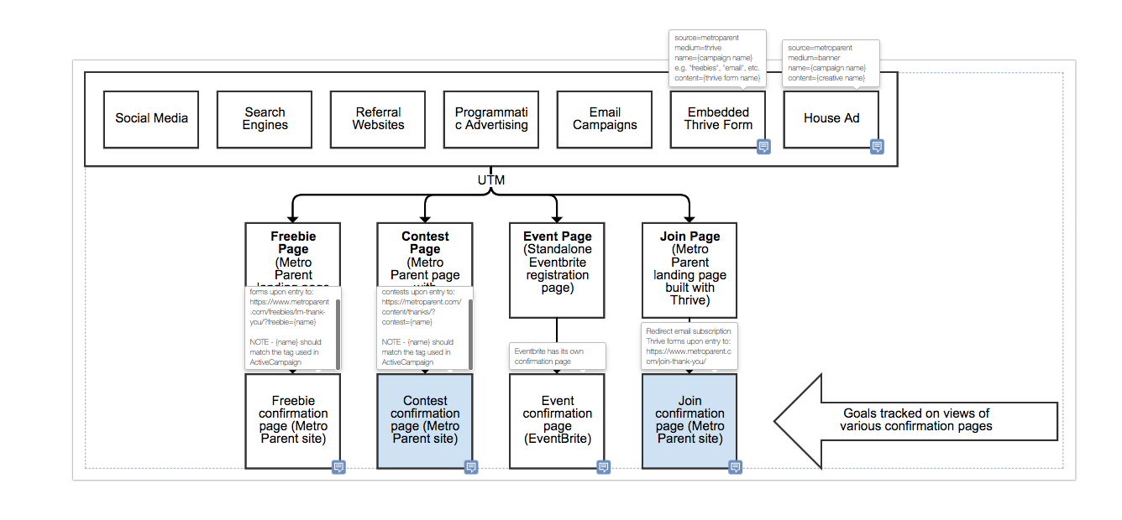

Ads for clients (Advertserve)
All ads for clients should have UTM codes that are added in maghub when the creative is ordered or logged in MagHub.

In general, all ads in one CAMPAIGN should have the same UTM code, unless there is a reason for differentiation. For example, if a client is SOV in a channel on MetroParent.com, but also gets run-of-site ads on the site, use one UTM code -- with medium=SOV -- for all ads running across the site. That will give the advertiser a way to track what’s coming from our site but not the ability to see how we manage the campaign on our end.

Add code using the Google URL Generator

Source=metroparent (or source=blac)
Medium=SOV
name=campaign_name (ie advertise_with_us)
content=creative (ie word_of_mom)

EXAMPLE: https://www.brainbalancecenters.com/?utm_source=metroparent&utm_medium=ros&utm_campaign=brain_balance&utm_content=

Some general guidelines:

Source: The source will always be either metroparent or blac (at this point)
Medium: For website display this is medium=ROS; for email it is medium=email; for audience extension (Google extensions through Advertserve) it is medium=AE; for programmatic it is medium=CPC (for cost per click).
Name: This is the name of the campaign. For Brain Balance it would be name=brain_balance_jan (or whatever distinguishes this campaign from another)
Content: This allows for identifying the actual content -- especially if there are different ads. This does NOT have to be filled in if all ads have the same theme

Ads for clients (Active Campaign -- email)

Add code using the Google URL Generator

Source=metroparent (or source=blac)
Medium=email
name=campaign_name (ie advertise_with_us)
content=creative (ie word_of_mom)

EXAMPLE: https://www.brainbalancecenters.com/?utm_source=metroparent&utm_medium=email&utm_campaign=brain_balance&utm_content=

