Virtual Camp: Tags, links and formats
Also in Google Forms: https://docs.google.com/document/d/1LDpguLBOvoy3RuyL-LHrI8GbwbZD9QBxRgbrVPInTVY/edit?usp=sharing

In Metroparent.com
- Every form in the Forms area it tied to Active Campaign via the Active Campaign Add-On (Forms is tied in Settings to Active Campaign).
- Every person who registers in the FORMS area is sent directly into Active Campaign and added to the list: MP Virtual Science Camp. This is the overall list used to communicate with anyone who has signed up (but not necessarily everyone has taken quizzes or engaged after signup)
- Every person who submits a quiz via Forms has their Active Campaign profile automatically updated, with a special CUSTOM FIELD created for Virtual Camps. (Next year, simply create a new set of virtual fields to accommodate the new quizzes, if the camp continues.)
- Every person who submits a quiz SHOULD have their time and date of submission recorded in Active Campaign via their email, which is the core identifier in Active Campaign.

Here’s how to tie each form to Active Campaign (see diagram below):

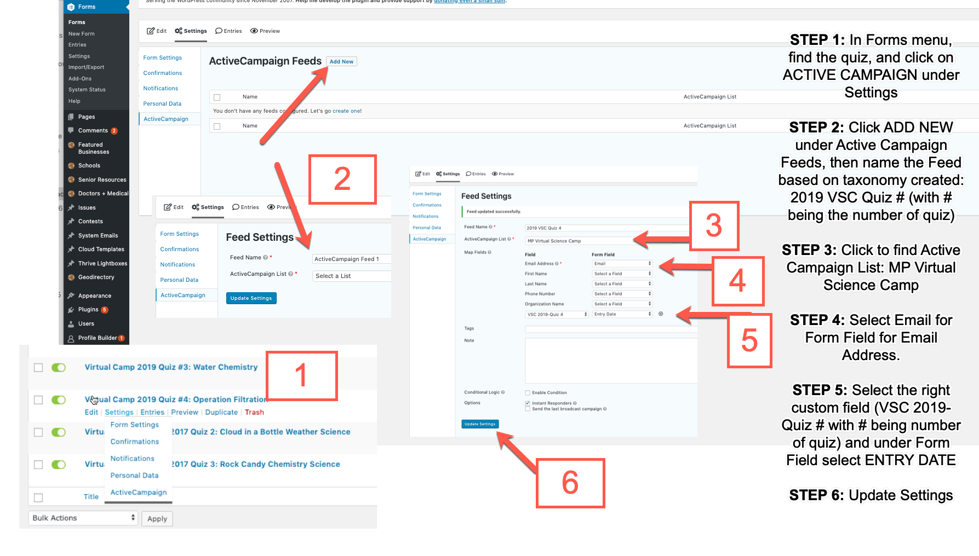

In Active Campaign
The Virtual Science Camp process in Active Campaign includes the following:
List: MP Virtual Science Camp is the list. This is the ongoing list of anyone who has signed up for Virtual Science Camp, and can be used year to year as an overall list to communicate with anyone who has registered and has not unsubscribed. If you have people who have asked to be added outside of the registration form, you can add them by importing contacts to this list. The list is the master for communicating with people about Virtual Science Camp (and the list used to send the weekly email).

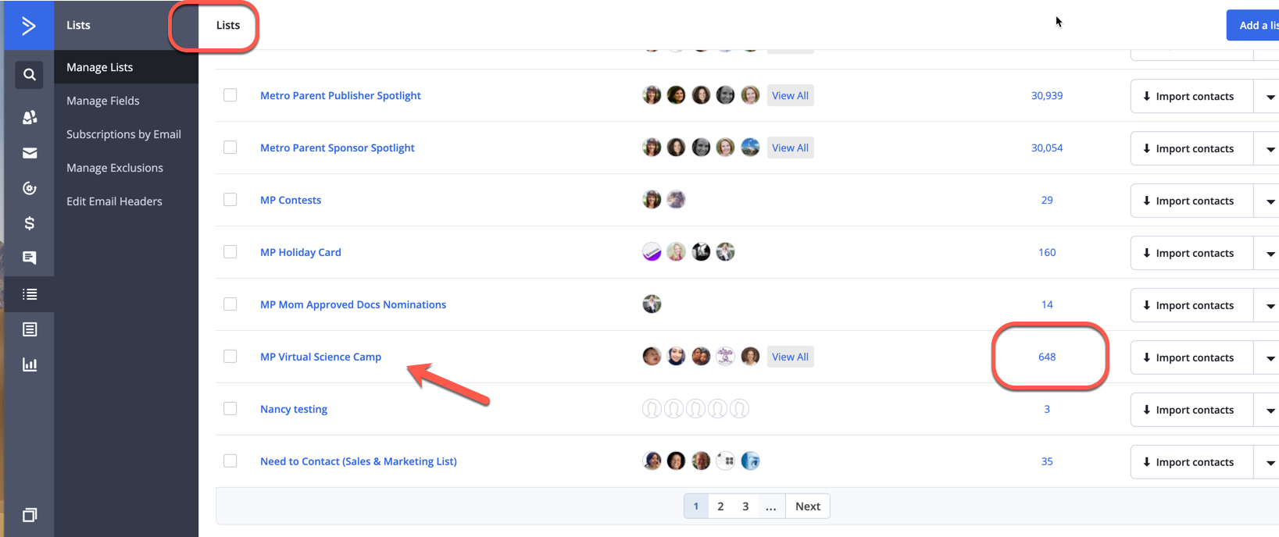

Tags: Tags allow for keeping track by year of anyone who is part of the Virtual Science Camp. So a new tag should be created each year. You will see here that there was an EVENT tag for last year (that is what I used to send to last year’s participants), while this year we changed to MP Virtual Science Camp 2018 to get away from the “event” nomenclature. Anyone who has this tag has it forever. The tag is for US, while the list is something that can be dynamic (someone can remove themselves from the list.)

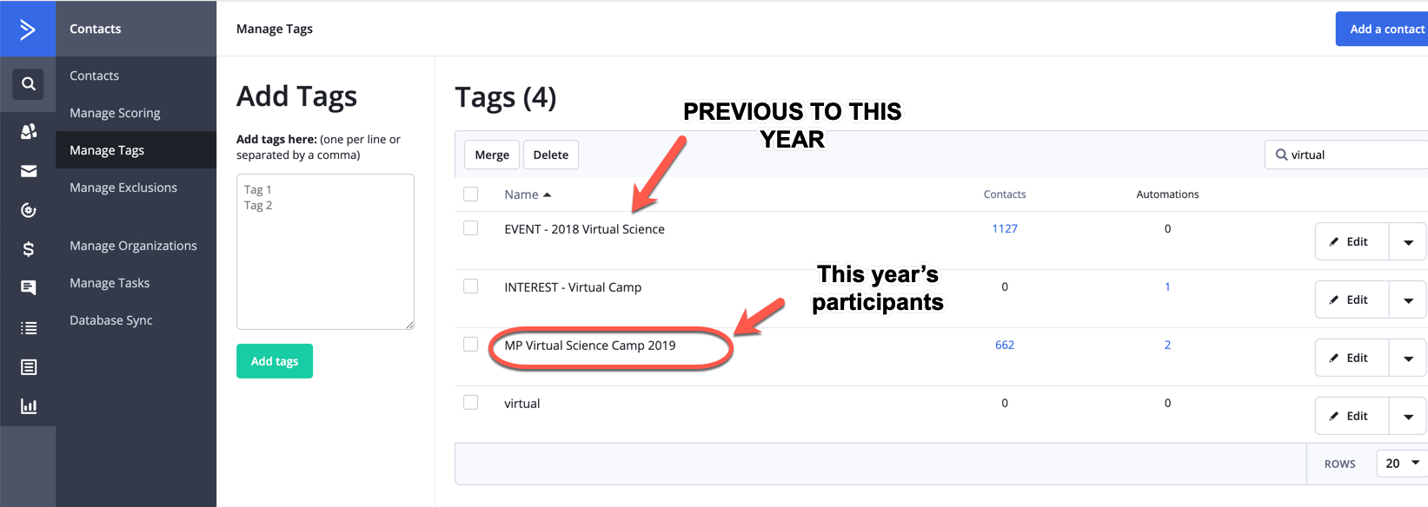

Automation: The main Virtual Camp automation uses the LIST to send a welcome email after someone registers then to take those participants through the series of emails introducing them to each lesson based on the weekly release OR based on when they join. If someone joins during Week 3, he or she will be moved through the series starting with Quiz 1 (and given they’ve opened the emails they get the others quickly after). Emails are added to the automation as they are created. This allows for tracking people based on what emails they open, what quizzes they take and how engaged they are.

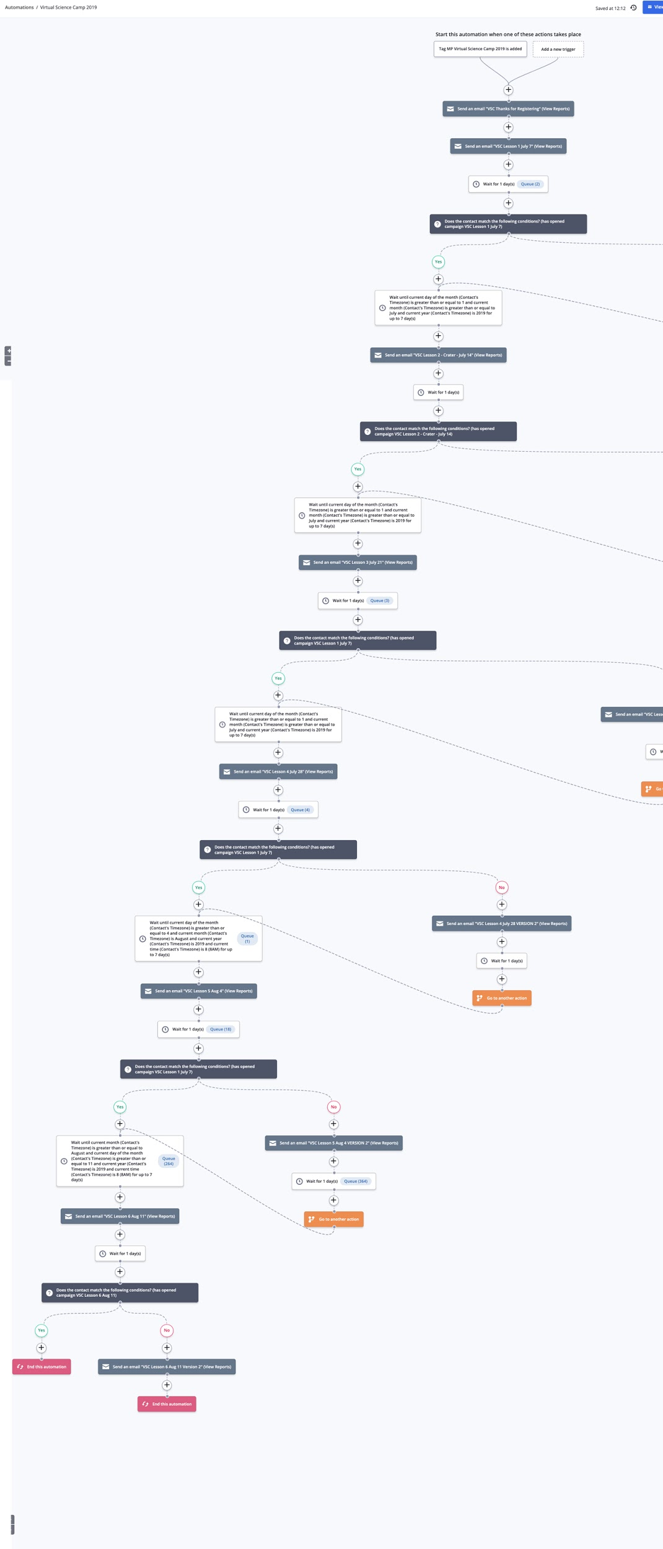
The automation uses date-based logic to release the weekly emails, but also allows for registered users to “catch up” and move through the quizzes. Someone may also find the quizzes and lessons online themselves … but if they are in the system they will get the series of emails.

Custom fields: Here’s where you can add and see the custom fields that tag users based on whether they take a quiz, and when -- and ultimately what will allow you to send the “final emails” to those who have taken a quiz and earned a pass (and a reminder to those who have not taken a quiz yet, if you want)

To add a custom field, simply click on the ADD FIELD button under MANAGE TAGS and add fields. There are unlimited custom fields, so you can add these for anything. These are the ones in Active Campaign already for all the quizzes for 2019.

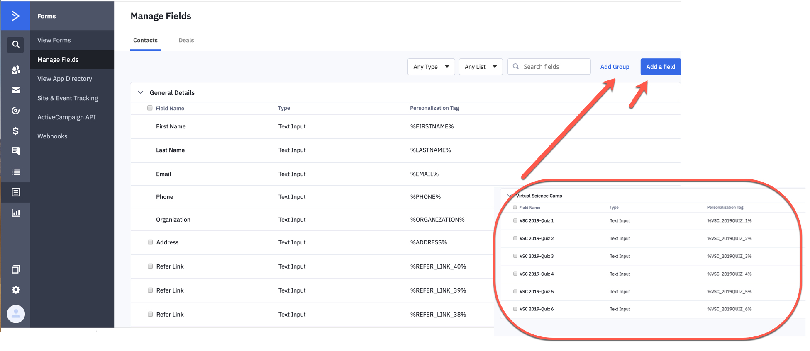
Because for Virtual Science Camp we’ve tied ENTRY DATE to Active Campaign’s custom field for each quiz, you can see the time and date each quiz was taken by each participant. Here’s one example:

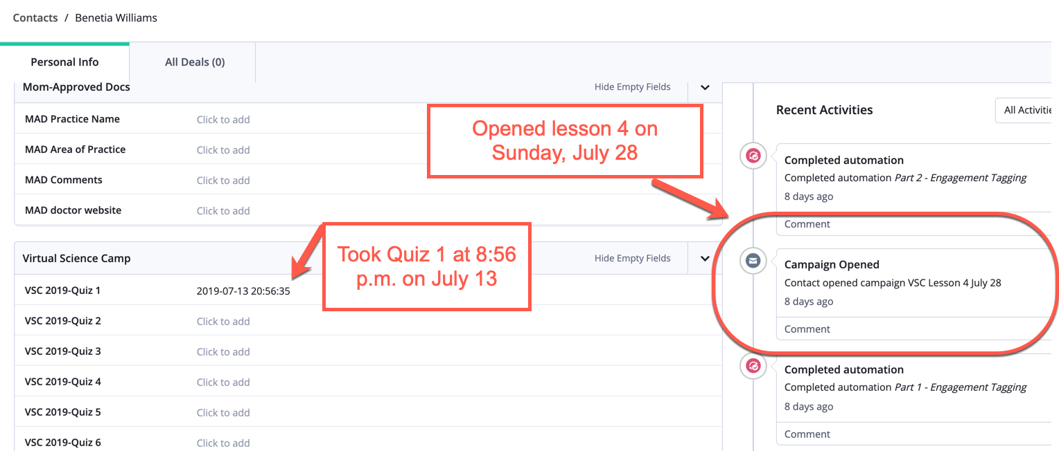

To find anyone who took any of the quizzes, use an advanced search of those on the MP Virtual Science Camp List and create a SUBSET to send to those people. You can also create a second SUBSET of those who haven’t taken any quizzes, so you can send final emails to those people urging them to go to the lessons and take a quiz so they can get a pass to MI-Sci.

(FYI, I exported the list from the website for Quiz 1 to compare to Active Campaign, and although Quiz 1 shows 54 submissions in MP.com and 37 emails in Active Campaign the AC list IS correct -- the 54 accounts for all duplicates. So you can be sure the emails you have in AC are accurate, and you do NOT need to import the MP names!!)

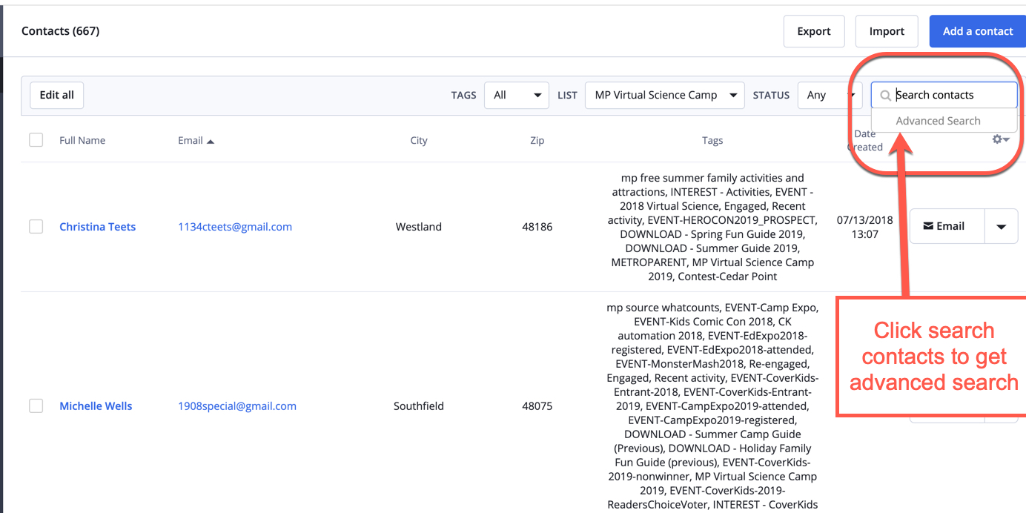

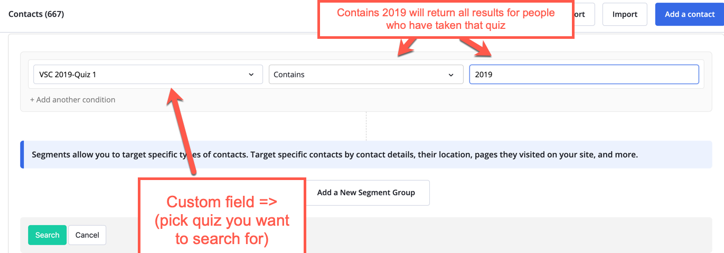

This is the list of people who have submitted Quiz 1

